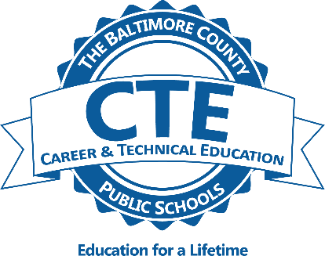
Information Technology:
Computer Science Pathway

Foundations of Computer Science (Prerequisite: None// Recommendation: C or higher achieved in Algebra 1)
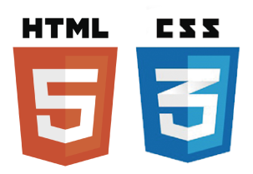
This course is designed to introduce students to the breadth of the field of computer science through an exploration of engaging and accessible topics. Rather than focusing the entire course on learning particular software tools or programming languages, the course is designed to focus the conceptual ideas of computing and help students understand why certain tools or languages might be utilized to solve particular problems. This course may also count as the Technology Education Graduation.

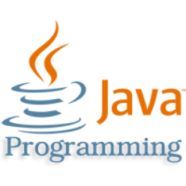
AP Computer Science Principles (Prerequisite: Successful completion of Foundations of Computer Science is required for pathway.)
This course advances students’ understanding of the technical aspects of computing including programming and algorithm design, computer system organization and operation, and data representation and information organization. This course includes the use of several programming languages, based on the specific project or problem students must solve. This course may also count as the Technology Education Graduation Requirement.

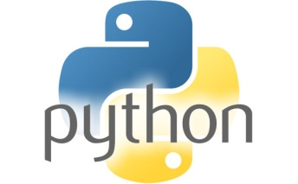
AP Computer Science A (Prerequisite: Successful completion of AP Computer Science Principles is required for pathway.)
This course is designed to provide students with a learning experience equivalent to that of an introductory college course in computer science. AP Computer Science A emphasizes object-oriented programming methodology with a concentration on problem solving and algorithm development, and includes the study of data structures, design, and abstraction.

Internship in Computer Science (Prerequisite: Successful completion of the preceding sequence of courses. Optional course; not required for completion of pathway.)

Students will have the option of completing an industry mentored project or internship.

*Contact Mrs. Scala at hscala@bcps.org for further information.

